**“MARKET SEGMENTATION ANALYSIS”**

A PROJECT REPORT

SUBMITTED TO

FEYNN LABS

BY

SAURABH BHADALE

BHARGAV KANTHETI

KUMAR SAMBHAV

RITURAJ SINGH

JUNE, 2022

**CONTENTS**

|  |  |  |
| --- | --- | --- |
| **Sr. No** | **Topic** | **Page No** |
| **1** | **Introduction** | **3-4** |
| **2** | **Step 1: Deciding to Segment** | **5** |
| **3** | **Step 2: Specifying the Ideal Target Segment** | **6-7** |
| **4** | **Step 3: Collecting Data** | **8-11** |
| **5** | **Step 4: Exploring data** | **12-16** |
| **6** | **Step 5: Extracting segments** | **16-19** |
| **7** | **Step 6: Profiling segment** | **20-22** |
| **8** | **Step 7: Describing segment** | **23-27** |
| **9** | **Step 8: Selecting the target segment** | **28-30** |
| **10** | **Step 9: Customising the Marketing Mix** | **31-32** |
| **11** | **Case Study: Fast Food** | **33** |
| **12** | **References** | **34** |

**INTRODUCTION**

Marketing is a logical sequence of activities leading to the setting of marketing objectives and the formulation of plans to achieve them. The strategic marketing plan typically identifies consumer needs and desires, strengths and weaknesses internal to the organization, and external opportunities and threats the organization may face.

Once organizational strengths have been established, potential interference by external factors has been assessed, and consumer needs and desires have been investigated. These decisions determine the long-term direction of the organization, and cannot easily be reversed. Tactical marketing planning usually covers a period of up to one year.

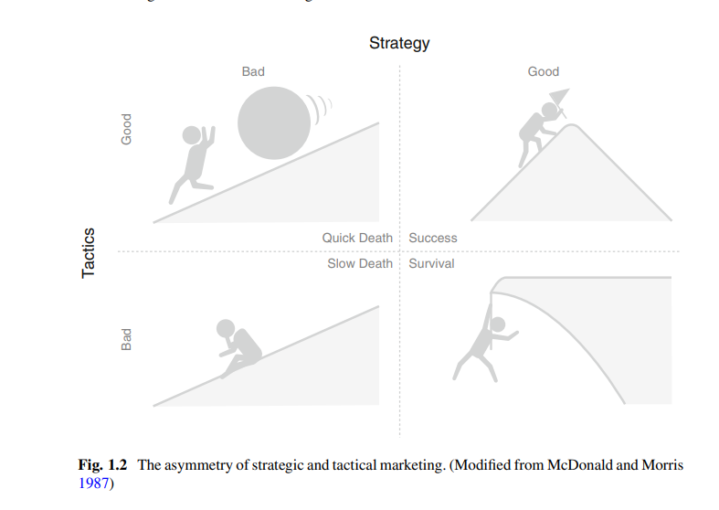

Strategic marketing is responsible for the equipment: the quality of the walking shoes, food, water, a raincoat. As long as the strategic marketing is good, the expedition leads to the right peak. Good strategic marketing combined with bad tactical marketing leads to failure, but this failure unfolds slowly.

Market segmentation is a decision-making tool for the marketing manager. Most successful firms drive their businesses based on segmentation, according to Lilien and Ranga swamy. Market segmentation sits between the two extreme views that all objects are unique and inviolable.

**The Benefits of Market Segmentation:**

Market segmentation allows organizations to take stock of where they stand, and where they want to be in future. It offers an opportunity to think and rethink, and leads to critical new insights and perspectives. When implemented well, it also leads to tangible benefits, including a better understanding of differences between consumers. A marketing mix developed to best reflect the needs of one or more segments is likely to yield a higher return on investment. For small businesses it may be essential to focus on satisfying very distinct needs of a small group of consumers rather than trying to serve a larger market or multiple market segments.

In the worst case, if market segmentation is not implemented well, the entire exercise is a waste of resources. If a segmentation strategy is pursued, more human and financial resources are required to develop and implement a customized marketing mix.

**Step 1: deciding to segment**

**Implications of Committing to Market Segmentation**

market segmentation has developed to be a key marketing strategy applied in many organisations. Before investing time and resources in a market segmentation analysis, it is important to understand the implications of pursuing a market segmentation strategy. The commitment to market segmentation goes hand in hand with the willingness and ability of the organisation to make substantial changes and investments. As cahill explain Segmenting a market is not free. There are costs of performing the research, fielding surveys, and focus groups, designing multiple packages

The modification of existing products, changes in pricing and distribution channels used to sell the product, as well as all communications with the market. These changes influence the structure of the organisation. Strategic business units in charge of segments offer a suitable organisational structure to ensure ongoing focus on the needs of market segments.

**Implementation Barriers:**

The very first implementation barriers are senior management. The factor like Lack of leadership, pro-active championing, commitment and involvement in the market segmentation process by senior leadership effect the success of market segmentation. Higher authority must see what is going on. A second group of barriers relates to organisational culture. Lack of market or consumer orientation, resistance to change and new ideas, lack of creative thinking, bad communication and lack of sharing of information and insights across organisational units, short-term thinking.

Another problem while doing segmentation is lack of training. If team tasked with segmentation or not having idea about the strategy Closely linked to these barriers is the lack of a formal marketing function or at least a qualified marketing expert in the organisation. The higher the market diversity and the larger the organisations, the more important is a high degree of formalisation.

Another barrier may be objective restrictions faced by the organisation, i.e lack of financial resources, or the inability to make the structural changes required. A lack of allocation of responsibilities, and time pressure that stands in the way of trying to find the best possible segmentation.

Most of these barriers can be identified from the outset of a market segmentation study, and then proactively removed. If barriers cannot be removed, the option of abandoning the attempt of exploring market segmentation as a potential future strategy should be seriously considered.

**Step 2: Specifying the Ideal Target Segment**

The results produce by market segmentation analysis is useful for an organisation. The user needs to be involved in most stages, literally wrapping around the technical aspects of market segmentation analysis. User have to see in multidisciplinary way.

After doing step 1, the organisation has to make a major contribution to market segmentation analysis in step 2. In Step 2 the organisation must determine two sets of segment evaluation criteria One set of evaluation criteria can be referred to as knock-out criteria. These criteria are the essential, non-negotiable features of segments that the organisation would consider targeting. The second set of evaluation criteria can be referred to as attractiveness criteria. These criteria are used to evaluate the relative attractiveness of the remaining market segments – those in compliance with the knock-out criteria. The shorter set of knock -out criteria is better. The segmentation team also needs to assess the relative importance of each attractiveness criterion to the organisation. Where knock-out criteria automatically eliminate some of the available market segments, attractiveness criteria are first negotiated by the team, and then applied to determine the overall relative attractiveness of each market segment in Step 8.

**Knock-Out Criteria:**

Knock-out criteria are used to determine if market segments resulting from the market segmentation analysis qualify to be assessed using segment attractiveness criteria. firstly, it was determined by Kotler and includes substantiality, measurability and accessibility.

The Knock-out criteria include that

The segment must be homogenous, distinct, large enough, identifiable, reachable.

Knock-out criteria must be understood by senior management, the segmentation team, and the advisory committee.

**Attractiveness criteria:**

Another criterion of segmentation is attractiveness. attractiveness criteria available to the segmentation team to consider when deciding which attractiveness criteria are most useful to their specific situation. Attractiveness criteria are not binary in nature.

**Implementing a Structured Process:**

segment evaluation plot is the most popular structured approach for evaluating market segments. The segment attractiveness and organisational competitiveness values are determined by the segmentation team. This is necessary because there is no standard set of criteria that could be used by all organisations. The segment evaluation plot cannot be completed in Step 2 of the market segmentation analysis because at this point no segments are available to assess yet. At the end of this step, the market segmentation team should have a list of approximately six segment attractiveness criteria.

**Step 3: Collecting Data**

Empirical data forms the basis for both common sense and data-driven market segmentation. In common sense segmentation, the segmentation variable is typically one single characteristic of the consumers in the sample. Describing segments is critical to being able to develop an effective marketing mix targeting the segment. Typical descriptor variables include socio-demographics, but also information about media behaviour, allowing marketers to reach their target segment with communication messages.

Good market segmentation analysis requires good empirical data. Optimally, data used in segmentation studies should reflect consumer behaviour. Survey data can be unreliable in reflecting behaviour, especially when the behaviour is of interest to a socially-conscious public (Karlsson and Dolnicar 2016).

**Segmentation Criteria:**

The term segmentation is used in a broader sense than that of segmentation variable. The most common segmentation criteria are geographic, socio- socio-psychographic, psychographic and behavioural. Cahill recommends using the simplest possible approach - do the least you can at the least possible cost.

**Geographic criteria:**

Geographic information is seen as the original segmentation criterion used for the purpose of market segmentation (Lewis et al. 1995; Tynan and Drayton 1987). The key advantage of geographic segmentation is that each consumer can easilybe assigned to a geographic unit. The location aspect has experienced a revival in international market segmentation studies aiming to extract market segments across geographic regions. The key disadvantage is that living in the same country or area does not necessarily mean that people share other characteristics relevant to marketers, such as lifestyle and interests.

**Socio Demographic criteria:**

Socio-demographic segments can be very useful in some industries. Typical segmentation criteria include age, gender, income and education. But in many cases, socio-demographics are not the cause for product preferences. Instead, values, astes and preferences are more influential in terms of buying decisions.

**Psychographic criteria:**

When people are grouped according to psychological criteria, such as their beliefs, interests, preferences, aspirations, or benefits sought when purchasing a product, psychographic segmentation is used. The word psychographics was intended as an umbrella term to cover all measures of the mind.

**Behavioural Segmentation:**

Another approach to segment extraction is to search directly for similarities in behaviour or reported behaviour. Behavioural data can include prior experience with the product, frequency of purchase, amount spent on purchasing the product on each occasion (or across multiple purchase occasions) and information search behaviour.

**Data from Survey Studies:**

**Choice of Variables**

Most market segmentation analyses are based on survey data. Survey data is cheap and easy to collect, but can be contaminated by a wide range of biases. Choosing the right variables for analysis is critical to the quality of the end-to-end solution. Noisy variables do not contribute any information necessary for the identification of the correct market segments. Instead, their presence makes it more difficult for the algorithm to extract the correct solution. The recommendation is to ask all necessary and unique questions, while resisting the temptation to include unnecessary or redundant questions.

**Response Options:**

Survey response options determine the scale of the data available for subsequent analyses. Not all survey response options are equally suitable for segmentation analysis. Many data analytic techniques are based on distance measures, such as distance measurements or logarithms. Ordinal scales dominate both market research and academic survey research. Using binary or metric response options prevents subsequent complications relating to the distance measure. The visual analogue scale allows respondents to indicate a continuous line between two end-points, and leads to data that can be assumed to be metric.

**Response Style:**

Survey data is prone to capturing biases. A response bias is a tendency to respond to a range of questionnaire items on some basis other than the specific item content (Paulhus 1991, p. 17). It is critical to minimise the risk of capturing responsestyles when data is collected for market segmentation.

**Sample Size:**

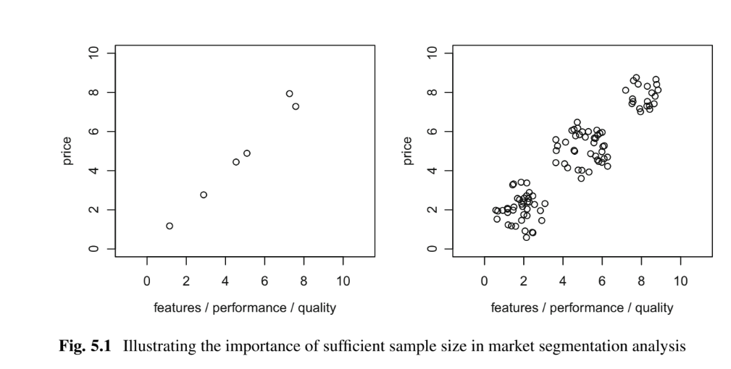

Figure 5.1 illustrates the problem any segmentation algorithm faces if the sample is insufficient. Viennese psychologist Forman (1984) recommends that the sample size should be at least2p (better five times 2p), where p is the number of segmentation variables. If segments are unequally sized, the smallest segment should contain a sample of at least 10 · p. The adjusted Rand index assesses the congruence between two segmentation solutions. The higher the effect, the better the algorithm identified the correct market segmentation solution.

Dolnicar et al. (2016) studied the effect of sampling characteristics on the correctness of artificial data segmentation algorithms. They found that increasing the sample size improved the accuracy of the reconstructions. For a more difficult artificial data scenario Dolnicar and colleagues recommend using a sample size of at least 70 · p.

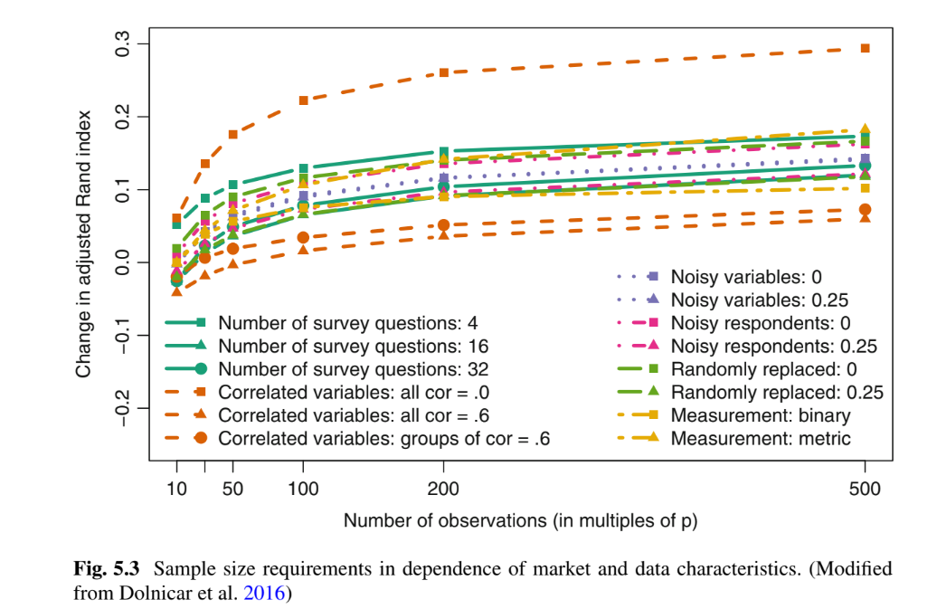

Larger sample sizes always improve an algorithm's ability to identify the correct market segmentation solution. But correlation cannot bewell compensated for by increasing sample size, as can be seen in Fig. 5.3. Dolnicar et al. (2016) recommend that data contains at least 100 respondents for each segmentation variable. The danger of using internal data is that it may be systematically biased by over-representing existing customers. What is missing is information about other consumers the organisation may want to win as customers in future, which may differ systematically from current customers in their consumption patterns.

**Data from Internal Sources:**

The strength of such data lies in the fact that it represents actual behaviour, rather than statements of consumers' intentions. Such data are usually automatically generated and stored in a format that makes them easy to access.

Data from Experimental Studies:

This response could then be used as a segmentation criterion. Another source of data that can form the basis for such analysis is experimental data, such as consumer choice experiments.

**Step 4: Exploring Data**

Data exploration helps to identify the measurement levels of the variables, investigate the univariate distributions of each of the variables and assess dependency structures between variables. The illustration done on the travel motives data set. Data set contains 20 travel motives reported by 1000 Australian residents in relation to their last vacation.

Index(['Gender', 'Age', 'Education', 'Income', 'Income2', 'Occupation',

'State', 'Relationship.Status', 'Obligation', 'Obligation2', 'NEP,'Vacation.Behaviour', 'rest and relax', 'luxury / be spoilt','do sports', 'excitement, a challenge', 'not exceed planned budget',

'realise creativity', 'fun and entertainment', 'good company','health and beauty', 'free-and-easy-going', 'entertainment facilities',

'not care about prices', 'life style of the local people',

'intense experience of nature', 'cosiness/familiar atmosphere',

'maintain unspoilt surroundings', 'everything organised',

'unspoilt nature/natural landscape', 'cultural offers',

'change of surroundings']

Dimension 1000 32

Summary of numerical variables

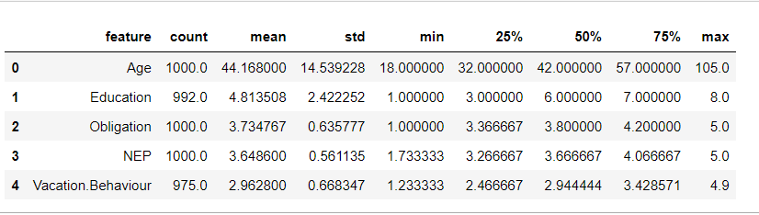

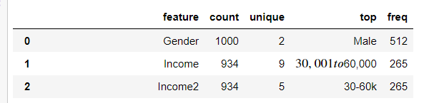

From the summary table we conclude that data contains 488 women and 512 men.The age of the respondents is a metric variable summarised by the minimum value (Min.), the first quartile (1st Qu.), the median, the mean, the third quartile (3rd Qu.), and the maximum (Max.). The youngest respondent is 18, and the oldest 105 years old. Half of the respondents are between 32 and 57 years old. Income2 consists of fewer categories than Income. The summary of the variables Income and Income2 indicates that these variables contain missing data. This means that not all respondents provided information about their income in the survey. Missing values are coded as NAs in R. NA stands for “not available”. The summary shows that 66 respondents did not provide income information

**Data cleaning:**

The first step before commencing data analysis is to clean the data. It is checking of all values recorded correctly for Eg age (in years) can be expected to lie between 0 and 110. It is point to errors during data collection or data entry. Similarly, levels of categorical variables can be checked to ensure they contain only permissible values. For example, gender typically has two values in surveys: female and male. Unless the questionnaire did offer a third option, only those two should appear in the data. Any other values are not permissible, and need to be corrected as part of the data cleaning procedure. Gender and Age indicates that no data cleaning is required for these variables. Ordinal and binary data are encoded with Label Encoding, which encodes their value into a range of integer starting from 0.

**Descriptive analysis:**

Descriptive numeric and graphic representations provide insights into the data. Helpful graphical methods for numeric data are histograms, boxplots and scatter plots. Bar plots of frequency counts are useful for the visualisation of categorical variables. Histograms reveal if the distribution of a variable is unimodal and symmetric or skewed

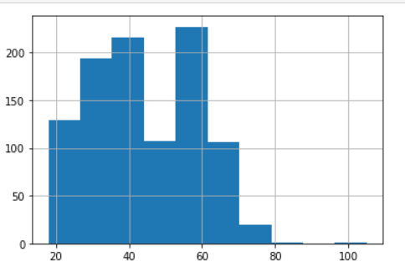

**Boxplot:** The box-and-whisker plot itself is shown in the middle row shown in below fig. It the representation of 5 number summary of the data i.e Q1, median, q3, Maximum, minimum .The top row shows the quartiles. The inner box of the box-and-whisker plot extends from the first quartile at 32 to the third quartile at 57. The median is at 42 and depicted by a thick line in the middle of the box. The inner box contains half of the respondents. The whiskers mark the smallest and largest values observed among the respondents, respectively.

Such a simple box-and-whisker plot provides insight into several distributional properties of the sample assuming unimodality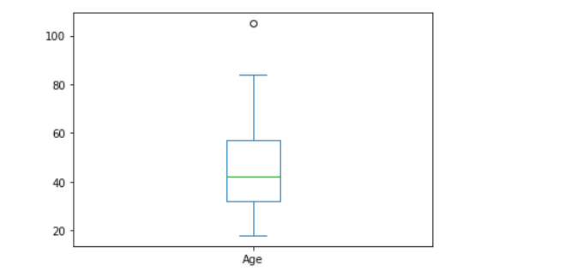

**Pre-processing:**

**Catogorical variables:**

Two pre-processing procedures are often used for categorical variables. One is merging levels of categorical variables before further analysis, the other one is converting categorical variables to numeric ones, if it makes sense to do so. There are many categorical variables few of them are bibary and some of the have multiple values. Therefore, we use label encoding for such cases and convert them to binary one.

**Numeric Variables:**

The values of the variables is not in same scale. Some variables are binary (with values 0 or 1 indicating whether or not a tourist likes to dine out during their vacation), and a second variable indicates the expenditure in dollars per person per day (and ranges from zero to $1000), a difference in spend per person per day of one dollar. To balance the influence of segmentation variables on segmentation results, variables can be standardised.

The default standardisation method in statistics subtracts the empirical mean x¯ and divides by the empirical standard deviation. Which can be done in python by using min max scalar

**Principal Components Analysis:**

Principle component analysis is data reduction technique. Principal components analysis (PCA) transforms a multivariate data set containing metric variables to a new data set with variables referred to as principal components. The first variable (principal component) contains most of the variability, the second principal component contains the second most variability, and so on. Principal components analysis works off the covariance or correlation matrix of several numeric variables.

In most cases, the transformation obtained from principal components analysis is used to project high-dimensional data into lower dimensions for plotting purposes. After performing coding principal components obtained are as follows:

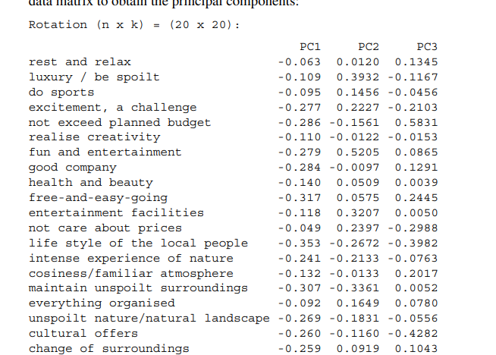

The column pc1 indicates how the first principal component is composed of the original variables. For the second principal component, the variables loading highest are fun and entertainment, luxury / be spoilt and to maintain an unspoilt surrounding.

The plot of principle components is as follows:

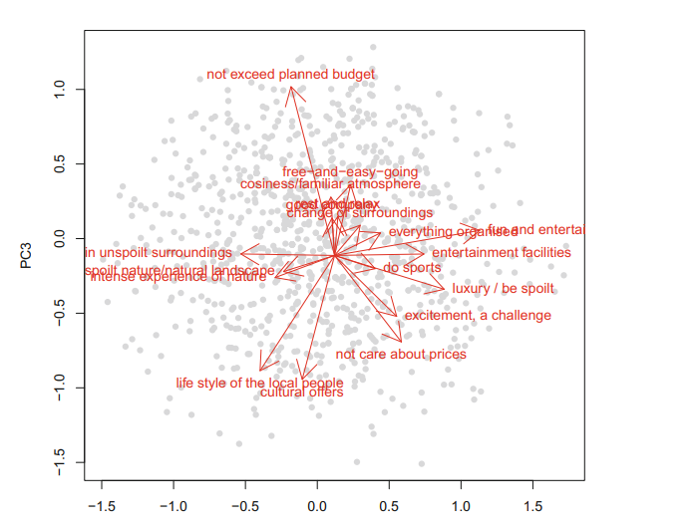

Sometimes principal components analysis is used for the purpose of reducing the number of segmentation variables before extracting market segments from consumer data. While using a subset of principal components as segmentation variables is therefore not recommended, it is safe to use principal components analysis to explore data, and identify highly correlated variables.

**Step 5: extracting segments**

Data-driven market segmentation analysis is exploratory by nature. Results are determined as much by underlying data as it is by the extraction algorithm chosen. Segmentation methods used to extract market segments are taken from the field of cluster analysis. It is important to understand how different algorithms impose structure on the extracted segments. One of the most illustrative examples of how algorithms impose structure is shown in Fig. 7. 1. k-means cluster analysis fails to identify the naturally existing spiral-shaped segments in the data. This is because it is designed to construct round, equally sized clusters. There is no single best algorithm for all data sets. If consumer data is well-structured, and well-separated, distinct market segments exist, tendencies of different algorithms matter less. If data is not well structured, however, the tendency of the algorithm can influence the solution substantially.

The size of the available data set indicates if the number of consumers is sufficient for the available number of segmentation variables, the expected number of segments, and the segment sizes. The minimum segment size required from a target segment has been defined as one of the knock-out criteria in Step 2. Step 3: The structure of segments extracted by the algorithm needs to align with expected characteristics. These features have, conceptually, been specified in Step 2, and need to be recalled here. This calls for the use of a model-based segment extraction algorithm.

**Distance Metric:**

In the example above, Anna's vacation activity profile is vector x1 = (100, 0, 0)′ and Tom's vacation activity profiles are vector x7 /(50, 20, 30)′. Mathematically, this is an n × p matrix where n stands for number of observations (rows) and p for the number of variables (columns). A distance measure has to comply with a few criteria. Most distance measures fulfil the so-called triangle inequality. Euclidean and Manhattan distance use all dimensions of the vectors x and y. The most common distance measures used in market segmentation analysis are d(x,y) and absolute distance.

The asymmetric binary distance does not use all dimensions of the vectors. It only uses dimensions where at least one of the two vectors has a value of 1. Similarity between two observations is only concluded if they share 1s, but not 0s. This has implications for market segmentation analysis.

The distance between Anna and Bill is zero because they have identical vacation activity profiles. The distance between Michael and all other people in the data set is substantial because Michael does not go to the beach where most other tourists spend a lot of time.

They both take a sum over all dimensions of squared or absolute differences. If the different dimensions of the data are not on the same scale, distances between them cannot be calculated.

**Model Based Methods:**

Distance-based methods have a long history of being used in market segmentation analysis. Model-based methodologies have attracted great interest from applied marketing researchers and consultants. These methods do not use similarities or distances to assess which consumers should be assigned to the same market segment. Property 1 states that members of each market segment have segment-specific characteristics. Function f() captures how likely specific values y are to be observed in the empirical data, given that the consumer has segment membership z. The values that need to be estimated are called parameters and are referred to as segments. An alternative statistical inference approach is to use the Bayesian framework for estimation. This approach exploits the fact that the likelihood of the complete data is easier to maximise. Maximum likelihood estimation with the EM algorithm requires specifying the number of segments k to extract in advance.

Information criteria are typically used to guide the data analyst in their choice of market segments. Most common are the or AIC, BIC and integrated completed likelihood or ICL. Criteria differ in the exact value of the penalty for the number of parameters estimated. The BIC penalises stronger than AIC for additional parameters, and prefers smaller models. The ICL uses an additional penalty, which takes the separatedness of segments into account. No one specific information criterion has been shown to consistently outperform the others in model-based clustering applications.

**Data Structure Analysis:**

Extracting market segments is inherently exploratory, irrespective of the extraction algorithm used. Validation in the traditional sense, where a clear optimality criterion is targeted, is therefore not possible. Cluster indices provide insight into particular aspects of the market segmentation solution. The external cluster index measures the similarity between two market segmentation solutions. Internal cluster indices use a single segmentation solution as a starting point. They consider how compact is each of the market segments? and (2) how well-separated are different markets segments? Idea for selecting the number of market segments for k-means clustering based on this internal cluster index is the scree plot. The scree plot visualises the sum of within-cluster distances Wk for segmentation solutions containing different numbers of segments k. No distinct elbow offers guidance to the data analyst. An optimal market segmentation solution contains market segments that are very different from one another, and contain very similar consumers. This idea is mathematically captured by another internal cluster index based on the weighted distances between centroids.

**External Clustering Indices**:

The true segment structure of consumer data is never known. When working with consumer data, the market segmentation solution obtained using a repeated calculation can be used as additional, external information. The repeated calculation could use a different clustering algorithm on the same data or apply the same algorithm to a variation of the original data. The Jaccard index takes values in [0, 1]. A value of J = 0 indicates that the two market segmentation solutions are completely different. Rand (1971) proposed a similar index based on all four values a, b, c and d:R=a+da+b+c+d. Both the Rand and Jaccard indices are based on the size of the extracted market segments. But – in each of the two solutions – the large segment contains so many consumers that 60% of them are still allocated to the same large segment, leading to high index values.

**Global Stability Analysis:**

Resampling is an alternative approach to data structure analysis that can be used for both distance- and model-based segment extraction techniques. Resampling methods offer insight into the stability of a market segmentation solution across repeated calculations. One such resampling approach is described in detail in this section. A consumer data can lack distinct, well-separated natural clusters, while not being entirely unstructured. In this case, the existing structure can be leveraged to extract artificial segments that re-emerge across repeated calculations. This case is referred to as reproducible segmentation. Bootstrapping generates new data sets that can be used to compute replicate segmentation solutions for different numbers of segments. Global stability analysis helps determine the most suitable number of segments to extract from the data. Dolnicar and Leisch (2010) recommend using bootstrapping techniques.

**Step 6: Profiling Segments**

**Identifying Key Characteristics of Market Segments**

The aim of the profiling step is to get to know the market segments resulting from the extraction step. Profiling is only required when data-driven market segmentation is used. For common sense segmentation, the profiles of the segments are predefined. At the profiling stage, we inspect a number of alternative market segmentation solutions. This is particularly important if no natural segments exist in the data, and either a reproducible or a constructive market segmentation approach has to be taken.

**Traditional Approaches to Profiling Market Segments**

We use the Australian vacation motives data set. Segments were extracted from this data set using the neural gas clustering algorithm with number of segments varied from 3 to 8 and with 20 random restarts. We reload the segmentation solution derived. Data Driven segmentation are usually represented in two ways. (1) as high-level summaries simplifying segment characteristics to a point where they are misleadingly trivial, or (2) as large tables that provide, for each segment, exact percentages for each segmentation variable.

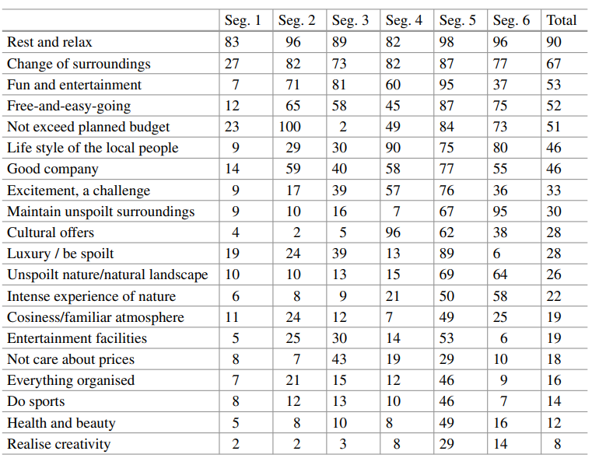

Theabove table gives exact percentage of members of each segment that indicate that each of the travel motives matters to them. To identify the defining characteristics of the market segments, the percentage value of each segment for each segmentation variable needs to be compared with the values of other segments or the total value provided in the far-right column. Sometimes – to deal with the size of this task – information is provided about the statistical significance of the difference between segments for each of the segmentation variables. This approach, however, is not statistically correct. Segment membership is directly derived from the segmentation variables, and segments are created in a way that makes them maximally different, thus not allowing to use standard statistical tests to assess the significance of differences.

**Segment Profiling with Visualisations:**

Using graphics to analyse data is an integral part of statistical data analysis. Graphics are particularly important in exploratory statistical alysis (like cluster analysis). In times of big and increasingly bigger data sets, visualisation offers a simple way of monitoring developments across many subsectors.

Table 8.1 sorts the 20 travel motives by the total mean (last column). Another option is to order segmentation variables by similarity of answer patterns. A segment profile plot shows – for all segmentation variables – how each market segment differs from the overall sample. The segment profile plot shows the total mean values for the segmentation variables across all observations. Marker variables are defined as variables which deviate by more than 0.25 from the overall mean. They are arbitrary and can be chosen by the data analyst and user as they see fit.

Table 8.2 contains the percentage of segment members indicating that each of the travel motives\r matters to them. Members of segment 2 are characterised primarily by not wanting to exceed their travel budget. Segment 4 is interested in culture and local people; members of segment 3 want fun and entertainment, and do not care about prices. Good visualizations facilitate interpretation by managers who make long-term strategic decisions based on segmentation results. Good visualizations, therefore, offer an excellent return on investment. It is well worth spending extra time on presenting results of a market segmentation as a well-designed graph.

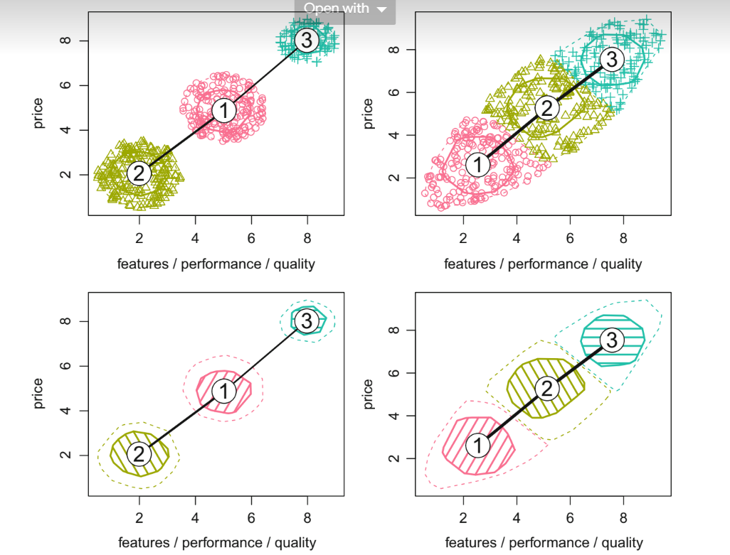

The artificial data visualised in Fig. 8.4 are two-dimensional, so no projection is required. Each plot contains three numbered nodes plotted at the position of the segment centres. The black lines connect segment centres, and\r indicate similarity between segments. We can use a number of different projection tech-\r niques, including some which maximise separation (Hennig 2004), and principal components analysis. We use the segmentation solution obtained from neural gas on page 171, and create a segment separation plot for this solution.

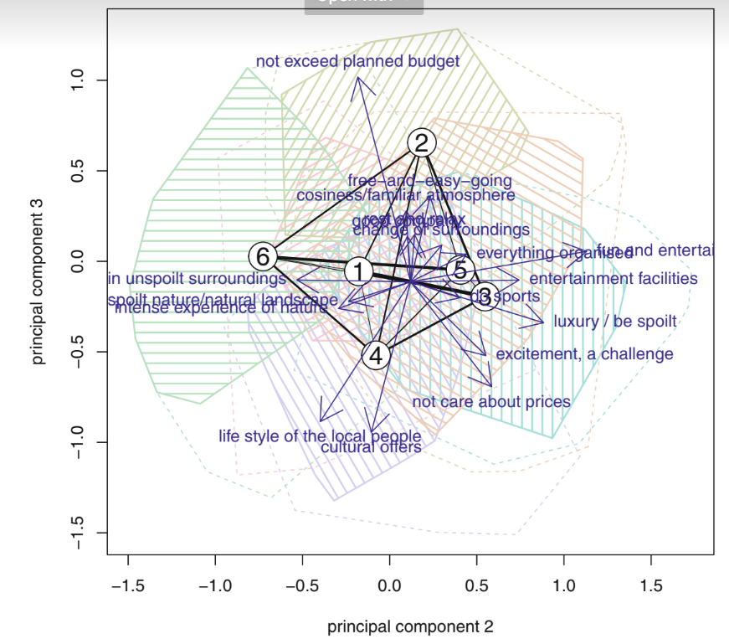

**Steps 7: Describing Segments**

**Developing a complete picture of market segments:**

Understanding differences in segmentation variables across market segments is the goal of segment profiling. Early in the market segmentation study process, segmentation variables are chosen conceptually in Step 2 (specifying the ideal target segment) and empirically in Step 3. (Collecting data). Market segments are extracted from empirical data using segmentation characteristics.

Profiling, for example, means looking into differences between segments in terms of the travel motives themselves when conducting a data-driven market segmentation analysis using the Australian travel motives data set (this is the segmentation solution we saved on page 171; the data is described in Appendix C.4). Figure 8.2 illustrates these profiles. Additional information is used in the segment description step, such as segment members' age, gender, previous travel behavior, preferred vacation activities, media use, use of information sources during vacation planning, or vacation spending tendencies. Descriptor variables relate to these additional variables.

**Using Visualisations to describe market segments:**

Differences in descriptor variables can be seen using a variety of visualizations. We cover two basic approaches that are appropriate for nominal and ordinal descriptor variables (such as gender, amount of education, and country of origin) as well as metric descriptor variables (such as age, number of nights spent at tourist sites, and money spent on accommodation).

**Stacked chart and Mosaic Plot:**

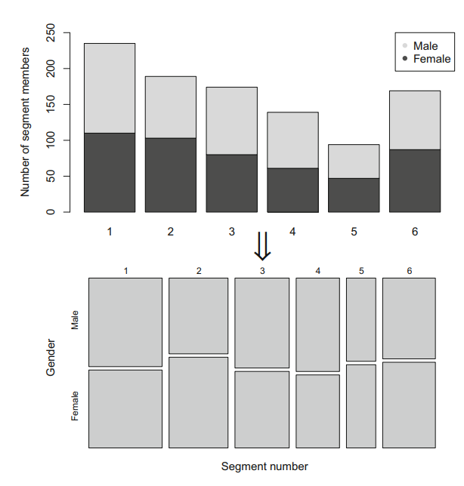

**Shaded Mosaic plot:**

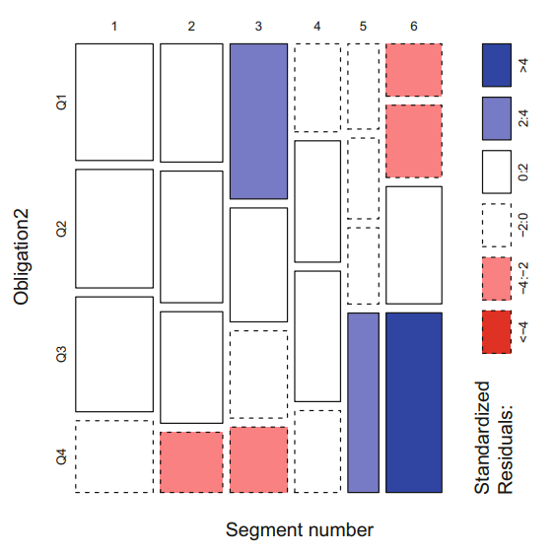

**Histograms:**

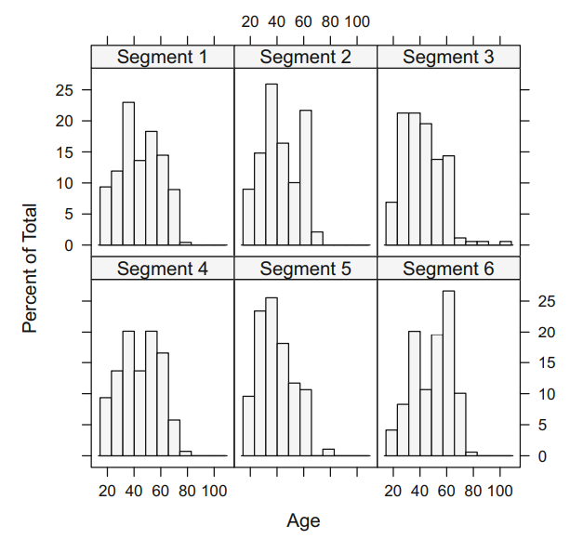

**Segment Level Stability Across Solutions (SLSA) plot**

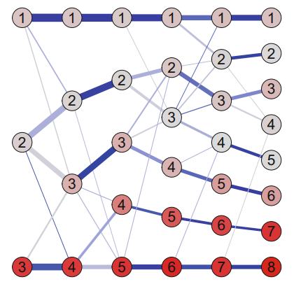

**Predicting Segments from Descriptor Variables:**

Another technique to learn about market segments is to use descriptor variables to predict segment membership. To do this, we utilize a regression model\swith the segment membership as the categorical dependent variable, and descriptor\svariables as independent variables. We can utilise methods developed in statistics for\classification, and methods developed in machine learning for supervised learning.

Regression analysis is the basis of prediction models. Regression analysis assumes that a dependent variable y can be predicted using independent variables

or regressors x1,..., xp: y ≈ f (x1,...,xp).

Regression models differ with respect to the function f (·), the distribution assumed for y, and the deviations between y and f (x1,...,xp). The basic regression model is the linear regression model. The linear regression model assumes that function f (·) is linear, and that y follows a normal distribution with mean f (x1,...,xp) and variance σ2. The relationship between the dependent variable y and the independent variables x1,...,xp is given by: y = β0 + β1x1 + ... + βpxp + epsilon

The normal distribution is not a requirement for generalised linear models. For example, we may employ the Bernoulli distribution with y values of 0 or 1. The mean value of y can only accept values in this scenario (0, 1). As a result, a linear function that may accept any real value cannot be used to express the mean value. A link function g( is introduced into generalised linear models to accommodate for this. The link function converts the mean value of y given by to an unbounded range indicated by a linear function can then be used to model this altered value: g(μ) = η = β0 + β1x1 + ... + βpxp.

**Binary Logistic Regression**

By assuming that f (y|) is the Bernoulli distribution with success probability and selecting the logit link that translates the success probability (0, 1) onto (−∞,∞), we may design a regression model for binary data using generalized linear models as



**Multinomial Logistic Regression:**

A model that predicts each segment simultaneously can be fitted using multinomial logistic regression. The dependent variable y is not binary since segment extraction usually results in more than two market segments. It's categorical, and it's supposed to follow a multinomial distribution with the logistic function as the link function.

**Tree-Based Methods:**

To fit the model, the tree technique employs a sequential procedure. Consumers are divided into groups based on one independent variable at each phase. The goal of the split is to produce groups that are as pure as feasible in terms of the dependent variable. This suggests that the dependent variable values for the consumers in the resulting groups are similar. A categorical dependent variable has the same value for all group members in the best-case scenario. The classification and regression tree approach is also known as recursive partitioning because of the sequential splitting procedure.

The nodes that emerge from each splitting phase are shown in the resulting tree. The root node is the node that contains all consumers.

Terminal nodes are nodes that aren't split any farther. Moving along the tree, we can forecast section membership. We move along the branch reflecting the consumer's independent variable at each node. When we get to the terminal node, we can forecast segment membership based on the segment memberships of the consumers in the terminal node.

**Step 8: Selecting the Target Segment**

Market segmentation is a strategic marketing tool. The selection of one or more target segments is a long-term decision significantly affecting the future performance of an organisation. After doing till step 7 i.e number of segments are available for detailed inspection. These segments are profiled in Step 6, and described in Step 7. In Step 8, one or more of those market segments need to be selected for targeting. The segmentation team can build on the outcome of Step 2. During Step 2, knock-out criteria for market segments have been agreed upon, and segment attractiveness criteria have been selected, and weighed to reflect the relative importance of each of the criteria to the organisation.

The knock-out criteria have already been applied in previous steps. The first task in Step 8, therefore, is to ensure that all the market segments that are still under consideration to be selected as target markets have well and truly passed the knock-out criteria test. Once this is done, the attractiveness of the remaining segments and the relative organisational competitiveness for these segments needs to be evaluated. In other words, the segmentation team has to ask a number of questions which fall into two broad categories: 1. Which of the market segments would the organisation most like to target? Which segment would the organisation like to commit to? 2. Which of the organisations offering the same product would each of the segments most like to buy from?

**Market Segment Evaluation:**

a decision matrix is used to see segment attractiveness and relative organisational competitiveness for each market segment. Boston matrix is type of matrix was first proposed by the Boston Consulting Group. And many peoples had developed various methodologies. Market segmentation team to decide which variation of the decision matrix offers the most useful framework to assist with decision making. The variation are choose on the basis of segment attractiveness, and relative organisational competitiveness specific to each of the segments.

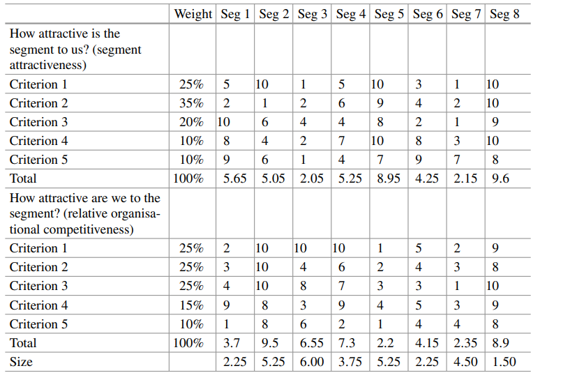

**segment evaluation plot**

In Step 8, the target segment selection step of market segmentation analysis, this information is critical. However, the piece of information missing to be able to select a target segment, is the actual value each market segment has for each of the criteria specified to constitute segment attractiveness. These values emerge from the grouping, profiling, and description of each market segment. To determine the attractiveness value to be used in the segment evaluation plot for each segment, the segmentation team needs to assign a value for each attractiveness criterion to each segment.

The value of each segment on the axis labelled How attractive are we to the segment? is calculated in the same way as the value for the attractiveness of each segment from the organisational perspective: first, criteria are agreed upon, next they are weighted, then each segment is rated, and finally the values are multiplied and summed up. The data underlying the segment evaluation plot based on the hypothetical example in below fig are given. The last aspect of the plot is the bubble size Anything can be plotted onto the bubble size. Typically profit potential is plotted. Profit combines information about the size of the segment with spending and, as such, represents a critical value when target segments are selected. In other contexts, entirely different criteria may matter. For example, if a non-for-profit organisation uses market segmentation to recruit volunteers to help with land regeneration activities, they may choose to plot the number of hours volunteered as the bubble size. Now the plot is complete and serves as a useful basis for discussions in the segmentation team Using below fig as a basis, the segmentation team may, for example, eliminate from further consideration segments 3 and 7 because they are rather unattractive compared to the other available segments despite the fact that they have high profit potential (as indicated by the size of the bubbles). Segment 5 is obviously highly attractive and has high profit potential, but unfortunately the segment is not as fond of the organisation as the organisation is of the segment. It is unlikely, at this point in time, that the organisation will be able to cater successfully to segment 5. Segment 8 is excellent because it is highly attractive to the organisation, and views the organisation’s offer as highly attractive.

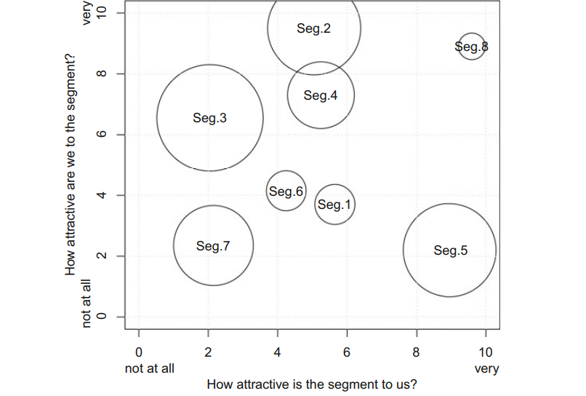

**Steps 9: Customising the Marketing Mix**

**Implications for Marketing Mix Decisions:**

The purpose of developing Marketing Insights from Customer Segmentation is to become a toolbox to assist sales. The main *postulates* considered for selling products well are:

* Product Planning
* Packaging
* Physical Handling
* Distribution Channels
* Pricing
* Personal Selling
* Branding
* Display
* Advertising
* Promotions
* Servicing
* Fact-Finding and Analysis

Market Segmentation goes in hand with marketing strategy, positioning, and competition. The “Target Segment” is divided into Product, Promotion, Price, and Place.

**Product:**

When defining the product dimension of the marketing mix, one of the most important decisions an organization must make is to identify the product in light of client needs.

Frequently, this does not entail creating a completely new product, but rather modifying one that already exists. Other product-related marketing mix considerations include branding the product, packaging it, providing or not providing warranties, and providing after-sales support services.

Possible product measures for the product targeted at this market group include the development of a new product. For example, a MUSEUMS, MONUMENTS & MUCH, MUCH MORE product (together with an activities pass) that assist members of this segment in locating activities that they are interested in and alerts them to the presence of these offers at the destination during the vacation planning process. Another way to reach this demographic is to make the destination's gardens a stand-alone attraction.

**Price:**

Setting the pricing for a product and choosing on discounts to be offered are two common decisions an organisation must make when building the price dimension of the marketing mix.

**Place:**

How to distribute the product to clients is the most important decision related to the place dimension of the marketing mix. This includes deciding if the product should be sold online alone, offline only, or both; whether the maker should sell directly to customers; and whether a wholesaler, retailer, or both should be used.

**Promotion:**

When creating a marketing mix, common promotion considerations involve creating an advertising message that will resonate with the target market and determining the most successful manner to communicate this message. Public relations, personal selling, and sponsorship are all tools in the promotion category of the marketing mix.

**Case Study: Fast Food**

**GitHub links:**

**1) Kumar Sambhav**

[**https://github.com/ksambhav21/Market-Segmentation-example**](https://github.com/ksambhav21/Market-Segmentation-example)**.**

**2) Saurabh Bhadale**

[**https://github.com/bhadal/Market-Segmentation-analysis**](https://github.com/bhadal/Market-Segmentation-analysis)**.**

**3) Bhargav Kantheti**

[**https://github.com/bharxhav/mcdonalds-market-segmentation**](https://github.com/bharxhav/mcdonalds-market-segmentation)**.**

**Reference:**

**1)** [**https://drive.google.com/file/d/1SIEt4Bp_4R9dcs4saU1DIui1IKWQIW38/view?usp=sharing**](https://drive.google.com/file/d/1SIEt4Bp_4R9dcs4saU1DIui1IKWQIW38/view?usp=sharing)**.**

**2)** [**http://www.marketsegmentationanalysis.org/**](http://www.marketsegmentationanalysis.org/)**.**

**3)** [**http://www.marketsegmentationanalysis.org/**](http://www.marketsegmentationanalysis.org/)

**4)** [**https://www.kaggle.com/ecemboluk/market-segmentation-with-clustering**](https://www.kaggle.com/ecemboluk/market-segmentation-with-clustering)

**5)** [**https://www.google.com/search?q=market+segmentation+analysis&rlz=1C1RLNS_enIN916IN916&oq=market+segmentation+analysis&aqs=chrome..69i57j69i60j69i65j69i60l2.10308j0j15&sourceid=chrome&ie=UTF-8**](https://www.google.com/search?q=market+segmentation+analysis&rlz=1C1RLNS_enIN916IN916&oq=market+segmentation+analysis&aqs=chrome..69i57j69i60j69i65j69i60l2.10308j0j15&sourceid=chrome&ie=UTF-8)**.**

**6)** [**https://pestleanalysis.com/market-segmentation-analysis/**](https://pestleanalysis.com/market-segmentation-analysis/)**.**